Overview of a few models

# Regression

# Classification

# Clustering

# Ranking

# Decision

This document illustrates the variety of models expressible in tabular, from the example sheets.

# Disclaimer

Note this is alpha-release, research software. When loaded, the add-in will sometimes crash Excel. However, it should not corrupt your Excel installation. We strongly recommend you save any other open Excel workbooks before using the add-in.

# Feedback

We welcome feedback and bug reports. Feedback may be sent to the Tabular Distribution Group [tabular-discussions](mailto:tabular-discussions@microsoft.com).

# Regression

Bayesian univariate linear regression

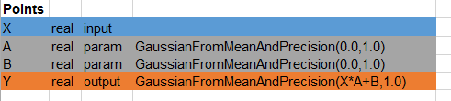

Bayesian multi-variate linear regression

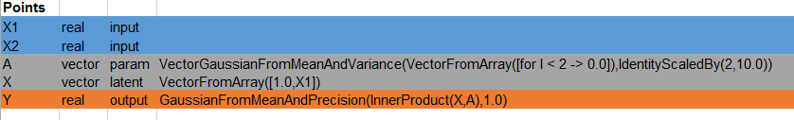

Hierarchical Linear Regression

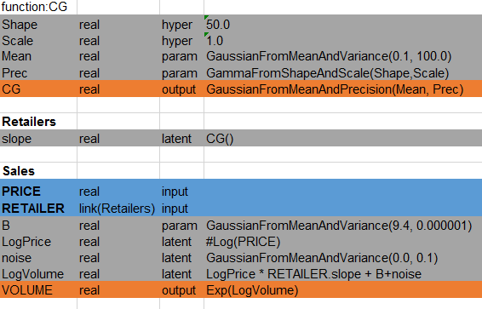

Hierarchical Multivariate Linear Regression

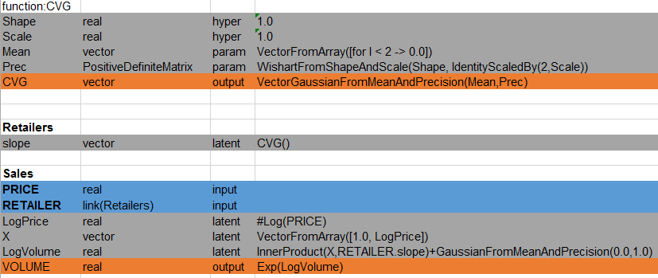

# Classification

Naïve bayes

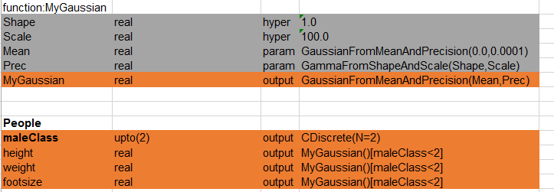

Logistic Regression

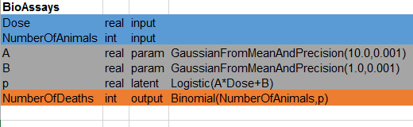

Multidimensional Logistic Regression

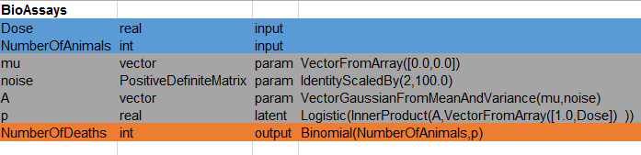

Bayes Point Machine

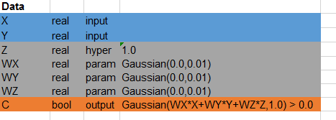

Multidimensional Bayes Point Machine

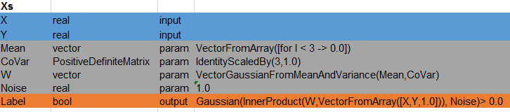

# Clustering

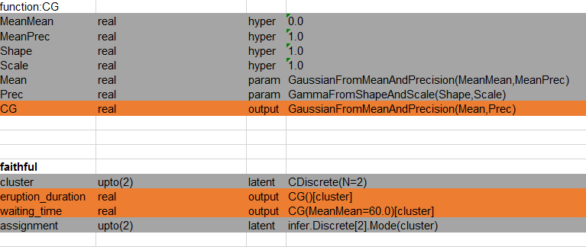

LDA

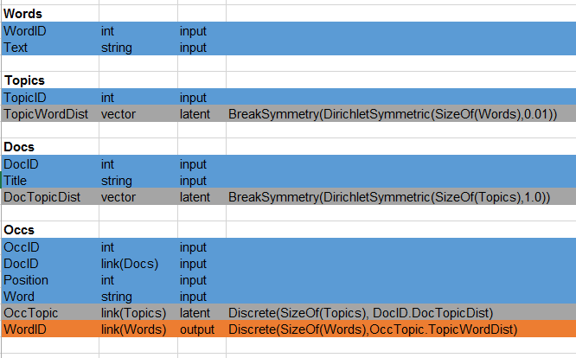

# Ranking

Trueskill

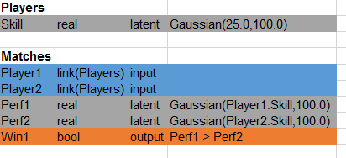

Recommender

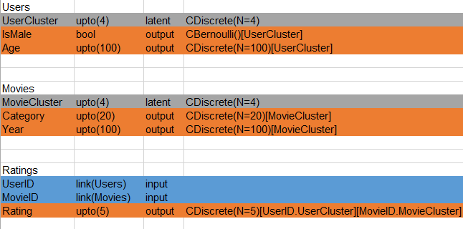

Matchbox

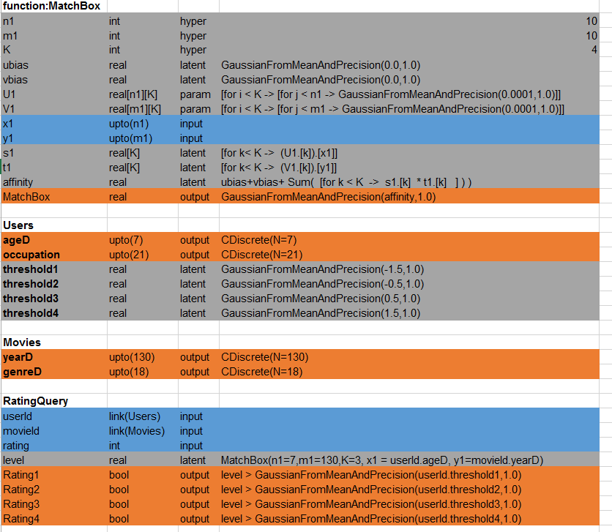

# Decision

